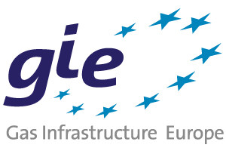
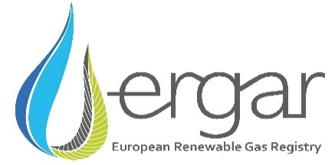

Power-to-Methane

Joint Workshop of EBA, GIE and ERGaR

European Biogas Association & Gas Infrastructure Europe &
European Renewable Gas Registry

06/09/2017, 10:00 – 16:00
Renewable Energy House
Rue d’Arlon 63-65, 1040 Brussels
Agenda

09:30 - 10:00 Registration
10:00 - 16:00 Workshop
16:00 - 17:00 Networking

Power-to-methane: A pathway to decarbonize the European gas grid (Introduction + setting the scene)
- Power-to-Methane: An Integral Part of Biomethane Industry
Jan Stambasky, EBA President
- Gas Demand Scenarios
Jan Ingwersen, ENTSOG General Manager
- Towards a sustainable future for gas transmission networks
Lajos Erdelyi, GIE Gas Infrastructure Europe

Update on the technological development
- Latest developments in Biological P2M
Thomas Heller, Technical Project Director, MicrobEnergy - Viessmann Group
- Latest developments in catalytical methanation
Serge Biollaz, Paul Scherrer Institute

Integrating new renewable gasses in Europe
- Handling of renewable gases
Jesper Bruun Sr, System Analyst Energinet
- Best practice: BioCat Project
Power-to-Gas facility at a wastewater treatment plant in Denmark
Dr. Doris Hafenbradl, CTO, Electrochaea
- The Importance of GoO in a Renewable Gas Markets
Attila Kovacs, ERGaR Secretary General

